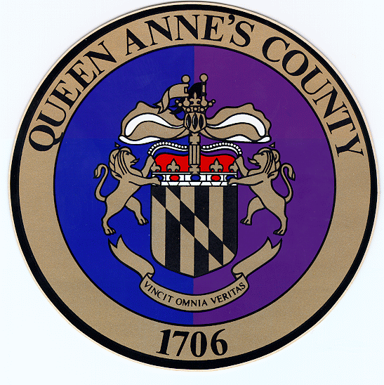
Queen

Anne’s

County
County Commissioners:
James J. Moran, At Large
Jack N. Wilson, Jr., District 1
J. Patrick McLaughlin, District 2
Philip L. Dumenil, District 3
Christopher M. Corchiarino, District 4

Department of Public Works
312 Safety Drive

Centreville, MD 21617

Telephone: (410) 758-0925
Fax: (410) 758-3441
www.qac.org

Water & Sewer Allocation FAQ
Matt Lucas, P.E.
Chief Sanitary Engineer - Queen Anne's Co. DPW

Q: What is allocation?
A: Allocation is the official reservation of water and/or sewer capacity for a property or development project. It ensures that the public system has the ability to serve the proposed use.

Q: How can developers or property owners obtain allocation?
A: Allocation is obtained through an application to the Sanitary District/County. It must match the property’s approved water and sewer service area in the County Water and Sewerage Plan and is granted based on available system capacity.

Q: What is a sewer or water service area?
A: A service area is a designated boundary in the County’s Comprehensive Water and Sewerage Plan (CWSP) that identifies where public water and sewer service is available now or planned in the future.

Q: I know my water and sewer designation – can I buy allocation?
A: Being in a service area does not automatically mean allocation is available. Allocation can only be granted if there is adequate system capacity and the project meets County requirements.

Q: What is a Water and Sewer Map Amendment?
A: A Water and Sewer Map Amendment is a formal change to the County’s Comprehensive Water and Sewerage Plan. It may adjust service area designations or facility planning to reflect growth, new projects, or infrastructure improvements. Amendments require review and approval by the County Commissioners and the Maryland Department of the Environment.

Q: Does allocation expire if I don’t use it right away?
A: Yes. Allocations typically have an expiration period if not used within a certain time. If construction does not begin or permits are not pulled, the allocation may revert back to the County for reassignment.

Q: Can I transfer my allocation to another property?
A: No. Allocation is tied to the specific property and project for which it was issued and cannot be sold or transferred.

Q: What happens if there isn’t enough capacity for my project?
A: Projects may need to wait until additional capacity becomes available through system upgrades or expansions. In some cases, projects may need to fund improvements to create capacity.

Q: Do I need allocation if I am on a private well or septic system?
A: No. Allocation only applies to properties connecting to County water or sewer systems. Private wells and septic systems are regulated separately by Environmental Health.

Q: How much does allocation cost?
A: Fees vary based on the type and size of the project. The County has established allocation and connection fees to recover the cost of providing public service.

Q: Who reviews my application for allocation?
A: The Department of Public Works (Sanitary District) reviews applications to confirm service area eligibility, system capacity, and compliance with County policy before allocation is issued.
Q: How often are allocations made available?
A: Allocation availability is reviewed and updated regularly based on system capacity, capital improvements, and demand.

