
Queen

Anne’s

County
County Commissioners:
James J. Moran, At Large
Jack N. Wilson, Jr., District 1
J. Patrick McLaughlin, District 2
Philip L. Dumenil, District 3
Christopher M. Corchiarino, District 4

Department of Public Works
312 Safety Drive

Centreville, MD 21617

Telephone: (410) 758-0925
Fax: (410) 758-3441
www.qac.org

Stormwater Management FAQ
Lee Edgar, P.E.
Chief of Engineering - Queen Anne's Co. DPW

Q: What is Stormwater Management?
A: Stormwater Management is the practice of intercepting and treating stormwater runoff from developed areas to minimize flooding, erosion and pollution of water bodies.

Q: What is Stormwater Runoff?
A: Stormwater runoff is rainwater or melted snow that discharges from streets, lawns, rooftops and other areas.

Q: Isn’t precipitation from storms a good thing?
A: When stormwater is absorbed naturally into soil, it is filtered, supports vital vegetation and crops, and ultimately replenishes the aquifers (groundwater) we rely on for irrigation and drinking water. This is known as the ‘Hydrologic Cycle’. However, when stormwater is unable to soak into the ground as a result of development, it quickly accumulates to a point where the runoff becomes harmful.

Q: What are the impacts of harmful stormwater runoff?
A: In developed areas, impervious surfaces such as pavement, rooftops, and even compacted soils or lawn area, restrict precipitation from naturally soaking into the ground. Instead, water runs rapidly into stormdrains, sewer systems and drainage ditches. As stormwater runoff accumulates, it can result in:
- Downstream flooding
- Stream bank erosion
- Increased turbidity (muddiness created by stirred up sediment) from erosion
- Habitat destruction
- Combined storm and sanitary sewer system overflows
- Infrastructure damage
- Contaminated streams, rivers and coastal water

Q: Why is Stormwater Management Important?
A: Stormwater management practices are designed to mitigate the harmful effects of excess stormwater runoff by achieving the following benefits:
- Flood Prevention:
Reduce rapid increases in runoff which can cause flooding and stream bank erosion
- Water Quality:
Remove pollutants from runoff before they enter groundwater, streams and lakes, protecting drinking water supplies, recreation and wildlife. In our region, the health of the Chesapeake Bay is particularly dependent upon clean runoff.
- Groundwater Recharge:
Some methods, such as rain gardens and permeable pavement, reintroduce filtered water back into the ground.

Q: What is the County’s role with Stormwater Management?
A: Since its original adoption in 1984, the County Stormwater Management Ordinance, today known as ‘Chapter 14’, is administered by the Department of Public Works (DPW) in concert with the Maryland Department of the Environment (MDE). For the review and approval of stormwater management plans, Public Works engineers rely on the County’s Ordinance and the Maryland Stormwater Design Manual developed by MDE.

Q: What is a Stormwater Management Plan?
A: Development plans – be it for a new subdivision, commercial building, single family dwelling or an addition to a home – have the potential to result in increased stormwater runoff. The County’s land use planning and permitting process requires that development plans are accompanied by a Stormwater Management Plan, which incorporates the installation of Best Management Practices (BMP’s) such as detention ponds, rain gardens, permeable pavement or other methods to intercept, filter and reduce runoff. BMP’s manage both the quantity and quality of stormwater.

Q: What is the difference between Quantity and Quality Stormwater Management?
A: Quantity management is the reduction of stormwater required to limit flooding. Quality management is the treatment of water to remove pollutants. Most stormwater BMP’s are able to provide both Quantity and Quality treatment; however, the efficiency of BMP’s for a given treatment varies.

Q: What are examples of stormwater management Best Management Practices (BMPs)?
A: Stormwater Best Management Practices (BMPs) are techniques or methods that manage the quantity and improve the quality of stormwater runoff in a cost-effective manner. BMPs often aim to replicate natural processes and, depending on their design, can offer social, environmental, and financial benefits to neighboring and downstream residences and community of the installed BMP. Examples of BMP’s include:
- Detention Ponds
- Grass Swales
- Bioretention (rain gardens)
- Permeable Pavement
- Rainwater Harvesting (rain barrels)
- Rooftop & Non-Rooftop Disconnection (lawn sheetflow)

Q: How are Stormwater Management Plans for new development implemented?
A: Developers or permittees submit proposed Stormwater Management (SWM) Plans for review and approval by DPW. SWM Plans range from complex designs prepared by engineering firms to simple ‘Single Lot Residential Plans’ which a homeowner can develop from templates available on the DPW website. Plans are reviewed by DPW and, when approved, become a condition of permit issuance. Larger developments require the posting of surety such as Performance Bonds, to guarantee satisfactory completion of the work.

Q: Do Stormwater BMP’s require maintenance?
A: Yes, all Stormwater Best Management Practices (BMPs) require maintenance to function effectively. Maintenance needs vary by BMP type, but commonly include routine activities such as removing trash, trimming vegetation as well as occasional non-routine renovations or repairs. The individual property owner or Homeowners Association (HOA) is typically responsible for maintaining BMP’s on private property. Stormwater BMP’s are typically subject to occasional inspection by DPW under a Maintenance and Inspection Agreement or other condition of the Stormwater Management Plan or Permit approval.

Q: Why does the Hydrologic Cycle look like?
A: The below graphic depicts a healthy, natural cycle to the left, and a harmful, ‘unmanaged’ cycle to the right:

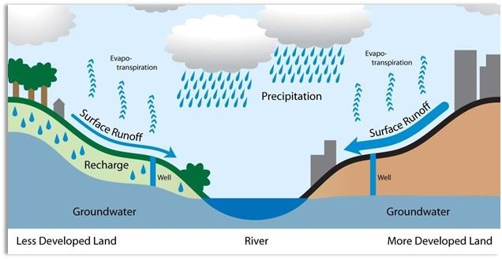

Q: Where can I learn more about Stormwater Management?
A: There are numerous on-line resources published by the Environmental Protection Agency (EPA), Maryland Department of the Environment (MDE) and even the Queen Anne’s County Department of Public Works; simply search ‘stormwater management’. Additionally, County public works staff are available to answer questions surrounding Stormwater Management and permitting requirements.

"Slow it down, spread it out, and soak it in.”

