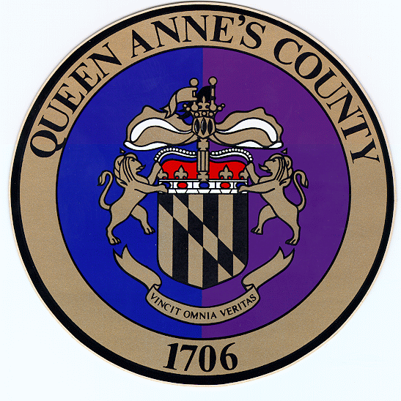
Queen

Anne’s

County
County Commissioners:
James J. Moran, At Large
Jack N. Wilson, Jr., District 1
J. Patrick McLaughlin, District 2
Philip L. Dumenil, District 3
Christopher M. Corchiarino, District 4

Department of Public Works
312 Safety Drive

Centreville, MD 21617

Telephone: (410) 758-0925
Fax: (410) 758-3441
www.qac.org

Traffic and Roads FAQ
Shane Moore, P.E.
Chief Roads Engineer - Queen Anne's Co. DPW

Q: How do I determine if a road is a State or County Road?
A: State roads are generally signed with a route number and name, i.e. MD Route 8 (Romancoke Road), MD 18 (Main Street), MD 552 (Dominion Road), where County roads are only signed with a road name, i.e. Cox Neck Road. Some roads such as Castle Marina Road and Piney Creek Road have both State and County portions. There are also several online maps that can provide road information and are very helpful.

Queen Anne’s County Property Viewer -
https://gis.qac.org/qac272/index.html?viewer=QAC_Property_Viewer.QAC_Property_Viewer

MDOT Know Your Roads -
https://www.arcgis.com/apps/webappviewer/index.html?id=14f27a6cab51422dabdfb168ca603482&extent=-9291536.3555%2C4387393.7597%2C-8117463.601%2C4960365.7237%2C102100

Q: How is a new County Road constructed?
A: New County roadways are completed in three ways. The first is when an existing private road is upgraded to current County Standards meeting County approval. The second is when a new road is constructed by a developer as part of a new subdivision. The third would be a project planned by the County. All roads must meet or exceed all standards set forth in the County’s Roads Design Manual.

Q: Who pays for new County Roads?
A: Private to Public Road upgrade projects are funded by the owner of the roadway or the property owners that benefit from the project. New County roads as part of a developer’s subdivision are funded by the developer including the bonding the construction costs as well as funding inspection of the construction. Road projects planned by the County are County funded or funded via an alternate funding source such as grants.

Q: Are existing County Roads improved as part of new or redevelopment?
A: Yes. Typical improvements identified by staff as part of the development review process include acquiring additional right-of-way, widening existing road lanes, adding turn lanes, addition of curb and gutter, sidewalks, relocating utilities, new pavement, crosswalks and new pavement markings and signage.

Q: Who pays for existing County Roads improvements as part of new or redevelopment?
A: Typically, the developer pays for required improvements identified by staff as part of the development review process, including bonding and inspection, however the County may choose to complete improvements in conjunction with the developer when it serves in the best interest of the community.

Q: Are State roads similarly improved through new and redevelopment?
A: Yes. As part of the development review process all plans are submitted for review and approval by the State Highway Administration. The County and State work together to review plans and identify needed improvements that must be addressed by the developer.

Q: Does the County accept a fee in-lieu for Road Improvements?
A: Yes. As development can happen piecemeal, when improvements extend farther than the developer’s property frontage or there is insufficient existing right-of-way for proposed improvements the County can accept a fee in-lieu and with future development the County can then complete the regional improvements.

Q: Development traffic impacts on existing County and State roads?
A: See Adequate Public Facilities Ordinance

