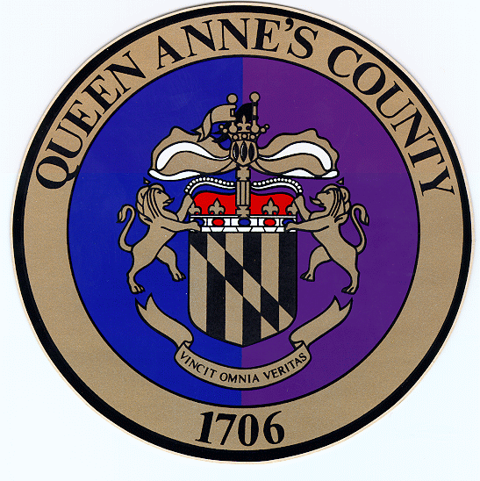
Queen

Anne’s

County
County Commissioners:
James J. Moran, At Large
Jack N. Wilson, Jr., District 1
J. Patrick McLaughlin, District 2
Philip L. Dumenil, District 3
Christopher M. Corchiarino, District 4

Department of Public Works
312 Safety Drive

Centreville, MD 21617

Telephone: (410) 758-0925
Fax: (410) 758-3441
www.qac.org

Floodplain Management FAQ
Lee Edgar, P.E.
Chief of Engineering - Queen Anne's Co. DPW
John Kling, CFM
Floodplain Manager - Queen Anne's Co. DPW

Flooding is the most prevalent of natural hazards in the State of Maryland. With nearly 500 miles of shoreline and nearly 3,000 structures within a regulated floodplain, Queen Anne’s County is no stranger to the effects of flooding. Be it storm surge, tidal, riverine or mere nuisance flooding, thousands of residents from Kent Island to North County are routinely exposed to the risk and dangers associated with flood events. The County’s floodplain management program assists residents in protecting themselves, their property and possessions, their finances, and communities.

Q: What is Floodplain Management?
A: Floodplain management is a community-based effort to prevent or reduce the risk of flooding, resulting in a more resilient community. Floodplain management regulations may be found in zoning codes, building codes or in stand-alone ordinances to correct or prevent future flood damage. Each community is responsible for managing and communicating their building codes and regulations in coordination with the Federal Emergency Management Agency (FEMA) and the National Flood Insurance Program (NFIP).

Q: What is the National Flood Insurance Program (NFIP)?
A: The NFIP is a federal program created by Congress to mitigate future flood losses across the country. The program enacts and enforces floodplain management regulations and provides access to government-backed flood insurance policies for property owners and renters within participating communities.

Q: How do communities such as Queen Anne’s County work with the NFIP?
A: The National Flood Insurance Act of 1968 allows FEMA to make flood insurance available through the NFIP only in communities that have adopted adequate floodplain management regulations for its Special Flood Hazard Areas (SFHAs), otherwise known as high-risk flood areas, or the ‘100-year floodplain’. The intent is to reduce future flood risks, with the federal government making flood insurance available to property owners and renters in that community in return. Queen Anne’s County is a participating community.

Q: What if the County chose not to enforce its Floodplain Ordinance or participate with the NFIP?
A: The increased vulnerability of structures notwithstanding, thousands of county residents would be subject to flood insurance rate increases or lost accessibility to federally-backed/discounted insurance and disaster assistance.

Q: My project is more costly as a result of the County’s Floodplain Ordinance; will I see a return on my investment?
A: According to the Insurance Information Institute, it is estimated that buildings constructed to NFIP standards suffer about 80% less damage annually than those not built in compliance. By employing wise floodplain management strategies, communities can protect against much of the devastating financial losses resulting from flood disasters.
Q: “80% less damage” sounds good, but is this truly our local experience, or merely a national statistic?
A: The storm surge which impacted Queen Anne’s County during Hurricane Isabel in 2003 saw floodwaters rise approximately seven feet (7’); which happens to coincide with the County’s Flood Protection Elevation (FPE). Structures built to the County’s flood protection standard generally suffered little to no damage.

Q: Who administers the County’s Floodplain Management Ordinance?
A: Since its original adoption in 1984, ‘Chapter 13’, or the County Floodplain Management Ordinance, is administered by the Department of Public Works in concert with the Department of Planning & Zoning, Maryland Department of the Environment (MDE) and FEMA. The County’s Floodplain Administrator relies on the County’s Ordinance and Flood Insurance Rape Maps (FIRMs) developed by FEMA for the NFIP.

Q: What are flood maps?
A: Flood Insurance Rate Maps (FIRMs) are the official community maps used as guides to indicate flood risk. Several levels of flood hazards are identified on these maps and are typically referred to as Special Flood Hazard Areas (SFHA) or flood zones.
Ordinarily in Queen Anne’s County, regulated flood zones are lands with a one-percent (1%) annual chance of inundation by floodwaters, more commonly referred to as the ‘100-year floodplain’. Don’t be fooled by the name, however; 100-year events can occur several years in a row.

Q: How are Flood Maps used?
A: Flood maps help us understand risks but are only part of the story. For example:
- Community officials use flood maps to understand and communicate local flood risk, manage floodplains and require new and substantially improved buildings be built to mitigate losses from future floods. These efforts help make a more resilient community in which to live and work.
- Mortgage lenders use flood maps to determine a property’s flood risk and decide whether to require flood insurance as a condition of a loan. Lenders generally require homeowners and business owners inside SFHAs to purchase flood insurance if they have a government-backed loan on the building, also known as the mandatory purchase requirement.
- Insurance professionals use the maps to help residents in all hazard areas protect their assets.
- Developers and builders use maps as part of location siting and construction decisions.
- Real estate professionals use maps to help clients make informed decisions about buying or selling a property, ensuring there are no surprises at the time of closing.

Q: Where can I view the Flood Map or FIRM for my property?
A: There are multiple resources through which one may assess their flood risk:
- Queen Anne’s County Property Viewer
https://gis.qac.org
- FEMA Flood Map Service Center
https://msc.fema.gov
- Maryland DFIRM Outreach Program
https://mdfloodmaps.net
- Queen Anne’s County Department of Public Works

Q: Are there other Floodplain Management resources?
A: Visit FEMA and the NFIP at www.FloodSmart.gov

